Nama : Steven

NIM : 2602119253

Below are figma link and reference and also some explanation about the website:

<https://www.figma.com/file/dGPv397zbBRTON3MXrs5u6/Project-HCI?type=design&node-id=0%3A1&t=lwaDjNc6CkRC3fQ9-1>

So this website is used for used selling watch product there are 5 pages in the website I will explain it below

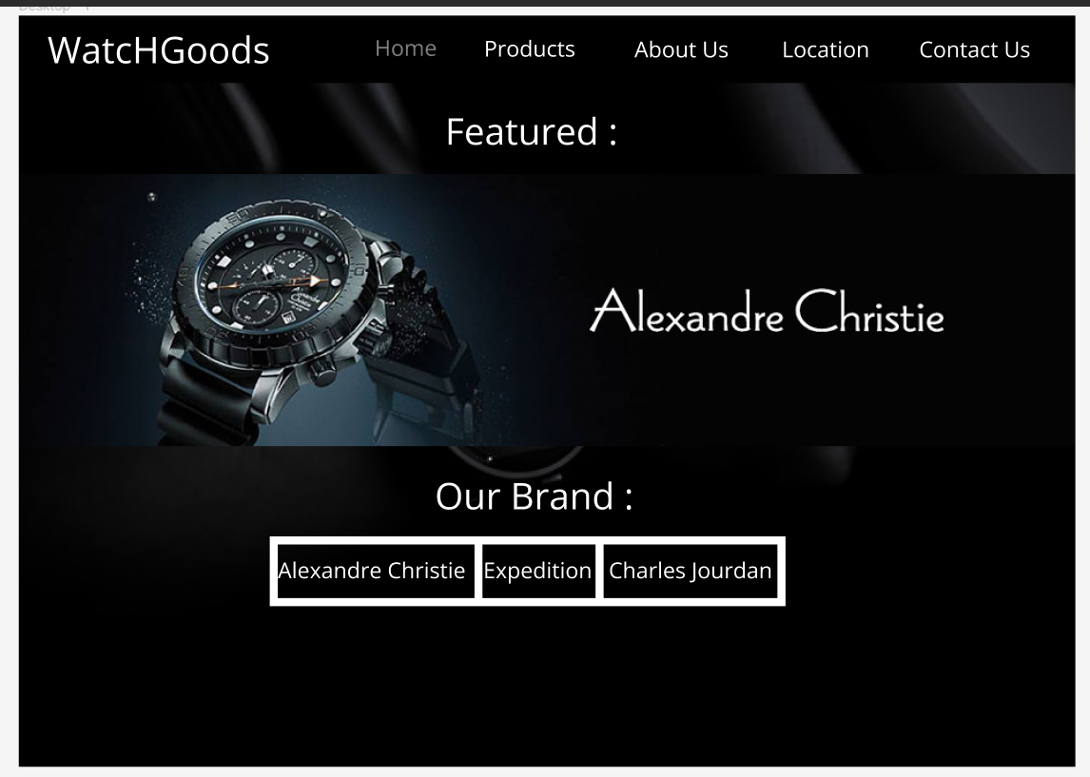

On this part of the page there is a brand advertisement that will be sold on the product page and below the advertisement there is a brand that will be sold and if we press this text it will move us to the product page.

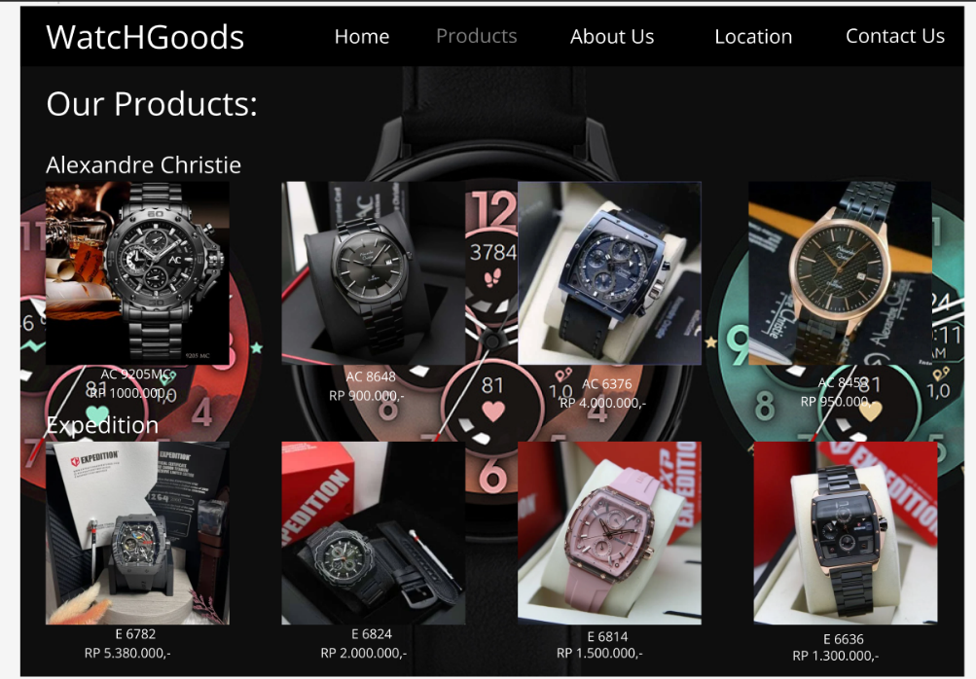

On this page it contains the products that are being sold, there are product names and prices for the watches and these products are lined up according to the brand name, so there is no need to bother anymore in finding the brand we want because the products have been categorized according to the brand.

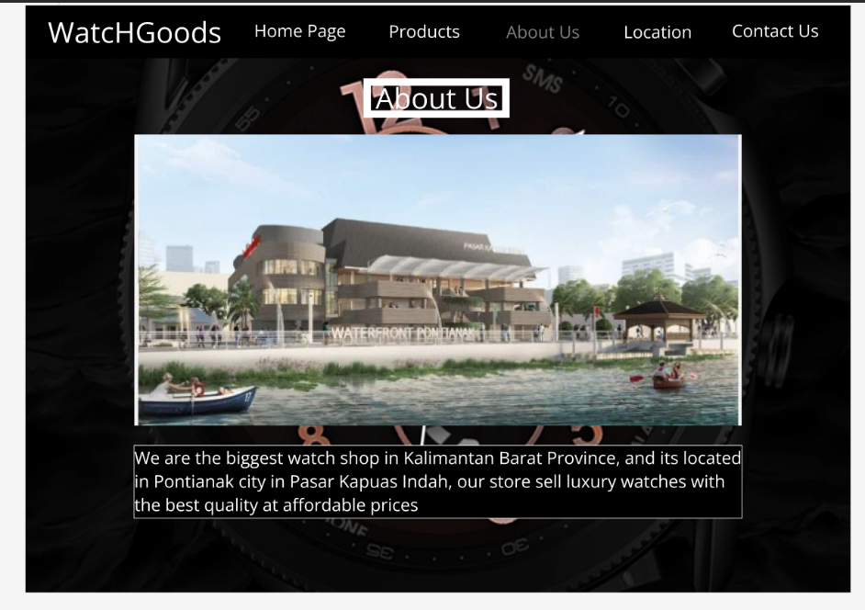

This page tells about some information about the store

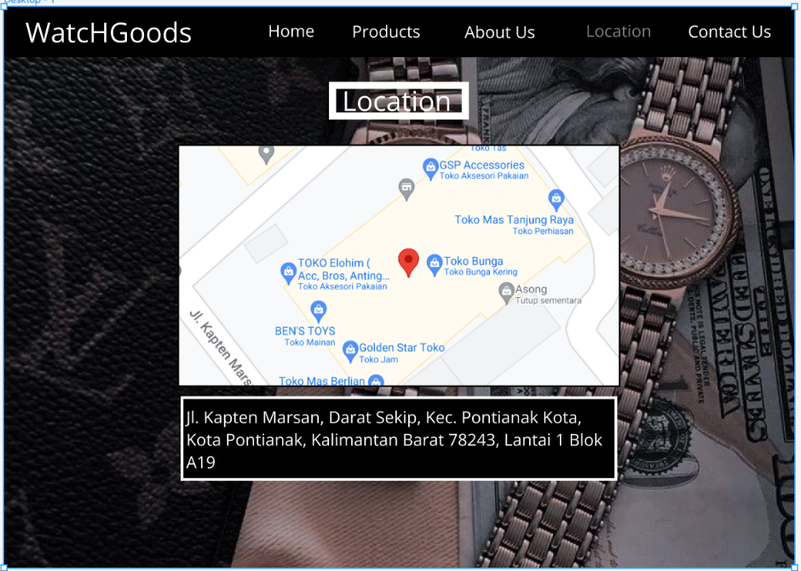

On this page there is the location of the offline store and those of us who want to go there directly can just press the image of the location and you will be rushed to Google Maps which leads to that location.A picture containing text, clock, screenshot

On this page we can complain or criticize the shop where before criticizing or complaining you have to fill in your name first then email so the shop can reply to your message via email then you also have to fill in your region so the shop can find out which city you are in , for the time being there are only a few cities that can be reached then after filling in which region you are in you can directly type your message in your message box then don't forget to check the agreement box because if you have checked the agreement box then you agree with the terms stated given then you can only submit your message then if there is an error filling out you can directly refill it or you can just press the reset button if you want to delete everything.

Reference Link

<https://www.alexandrechristie.com/>

<https://shopee.co.id/>

<https://www.tokopedia.com/>

|  |  |
| --- | --- |
| **Project Case** |  |
| COMP6232001 | COMP6800 | COMP6800001  Human and Computer Interaction |
| **Computer Science** | **E232-COMP6800-HG06-00** |
| ***Valid on*** *Even Semester Year 2022/2023* | **Revision 00** |

1. Kelompok tidak diperkenankan untuk:

*Members of the group are prohibited from:*

* + - Melihat sebagian atau seluruh jawaban kelompok lain,

*Seeing a part or the whole answer from other groups,*

* + - Menyadur sebagian atau seluruh jawaban dari buku, catatan, video, dan jenis referensi lainnya,

*Retell a part or the whole answer from books, notes, videos, and other references,*

* + - Menyadur sebagian atau seluruh jawaban dari internet,

*Retell a part or the whole answer from the internet,*

* + - Mengumpulkan jawaban yang tidak sesuai dengan tema soal,

*Submitting an answer with a different theme from the given case,*

* + - Melakukan tindakan yang menyebabkan jawaban dicontek oleh orang lain atau kelompok lain, baik disengaja maupun tidak disengaja,

*Doing action that could result the answer being copied by someone or other groups, intentionally or unintentionally,*

* + - Melakukan tindakan kecurangan lainnya.

*Committing other dishonest actions.*

1. Jika kelompok terbukti melakukan tindakan seperti yang dicantumkan pada butir ke-1, maka nilai mahasiswa dan/atau kelompok yang melakukan kecurangan, baik menyontek atau dicontek, akan dinolkan sesuai dengan peraturan yang berlaku.

*If it has been proven that a group has committed dishonest actions outlined in point 1 above, the whole groups related to the incident, regardless of which one copies or has their answer copied, will be issued a score of zero according to the regulation.*

1. Jawaban yang dapat diterima dan dinilai adalah jawaban yang dikumpulkan sebelum batas waktu yang telah ditentukan.

*The answer must be submitted before the designated deadline to be accepted and graded,*

1. Jawaban akan dinilai berdasarkan teknik atau metode yang diajarkan pada kelas praktikum dengan menggunakan software yang sudah ditentukan.

*The scoring will be based on the materials taught during the practicum classes using the designated software. Using different software than requested may result in your answer not being graded.*

1. Jika Anda tidak membaca peraturan ini, maka Anda dianggap sudah membaca dan menyetujuinya.

*By taking this exam, you agree to these regulations, regardless of whether you have read it or not.*

1. Persentase penilaian untuk matakuliah ini adalah sebagai berikut:

*The score will be distributed as follows:*

|  |  |  |
| --- | --- | --- |
| **Tugas Mandiri**  *Assignment* | **Proyek**  *Project* | **UAP**  *Final Exam* |
| - | 100% | - |

1. Perangkat lunak yang digunakan pada matakuliah ini adalah sebagai berikut:

*This course uses the following software:*

|  |
| --- |
| **Software**  *Software* |
| Chrome / Firefox / Microsoft Edge  Figma  Visual Studio Code |

1. Ekstensi file yang harus dikumpulkan untuk matakuliah ini adalah sebagai berikut:

*Your answers must be in the following file extensions:*

|  |  |  |
| --- | --- | --- |
| **Tugas Mandiri**  *Assignment* | **Proyek**  *Project* | **UAP**  *Final Exam* |
| - | FIG, HTML, CSS, JS, Image Files (JPG / PNG) | - |

1. File yang harus dikumpulkan adalah keseluruhan jawaban beserta dengan aset yang digunakan (gambar, audio, video, dll) dan dokumentasi proyek yang berisikan link referensi aset dan penjelasan mengenai aplikasi yang dibuat (terlampir bersama dengan soal).

*Include other files that can support your project, such as: all files in your project, other files (image, audio, video, etc.) used in your project, *.doc file (documentation of your project) that contains all pages in your project, reference links of additional files (image, audio, video, etc.) used in your project, the description about how to use your application, etc.*

## Soal

*Case*

**WatcHGoods**

**WatcHGoods** is home to the greatest collection of used luxury watches, all certified as authentic and Collector Quality. With the growth of information technology, **WatcHGoods** plans to dive into the world of digital business. **WatcHGoods** entrust you as a web designer to design their **website** **prototype** and create the **company** **website**. First, **WatcHGoods** must create a **website** **prototype** and **company** **website** that represents **WatcHGoods** image. With this website's existence, **WatcHGoods** hopes they can improve their service towards their customers.

The **requirements** from **WatcHGoods** are described below:

* + - 1. **WatcHGoods** wants you to design the **website** **prototype** of all **five pages** before making the HTML files. The **website** **prototype** will be created using **Figma**. Ensure the **website** **prototype** that you created is the **exact same** as the website that you will make later. Each pagewill contain **header**, **navigation**, **content,** and **footer** as its structure. Consider the **color**, **layout**, and **consistency** when designing the prototype.
      2. **WatcHGoods** wants you to build the **website attractive**, **appealing** and **fully functional**, and make sure the website is **responsive**. The website should be accessible using a mobile phone in a perfect way. To achieve that, use **5 kinds of CSS property** and **JavaScript**. Use **Meta** **viewport** **tag** and **media** **screen** **rule** that will be applied if the screen is **below** **800px** screen width.
      3. The website consists of **five main pages**. They are **Home Page**, **Products Page**, **About Us Page**, **Locations Page**, **Contact Us Page**. Below are the **requirements** for each page:
  1. **Home**

This page shows the **all the WatcHGoods attributes** (quality, service, authenticity, etc.)and **promotion** **banner** for the customer. This page also shows **all** **watch brands** in **WatcHGoods**.

* 1. **Products**

This page shows **a list of watches** that are currently being sold at the store. **WatcHGoods** wants the **watch** to be **categorized according to its brand**. Each **watch** has its own **information**, such as the **watch** **image**, **name**, and **price**.

* 1. **About Us**

This page shows **information about the** **store’s description** along with some **photos** for decoration.

* 1. **Locations**

This page shows **the locations** of **WatcHGoods physical stores** around the world. In this page, each location will have its own **information**, such as **image**, **city/store name**, and **country**.

* 1. **Contact Us**

This page shows the store’s **contact form** for the customer. Customer needs to submit some **personal information**, such as **full name**, **email**, **country region**, **email body (message),** and a **agreement** to receive a copy of their message. You are also asked to create **5 kinds of form components** and **5 kinds of validation**. For validation, you must create it using **JavaScript** and **don’t use regular expression**.

**Guidelines:**

* + - * 1. Design your website by observing the principles of **human and computer interaction**. Set up your site as creative as possible but still strive for **consistency**.
        2. The **website prototype** must be designed using **Figma** and make surethese **features** are used:
* Color Style & Text Style
* Effects
* Components
* Variants & Interactive Component
* Navigation
  + - * 1. Consider the **color**, **font**, **image**, **size,** and **layout** that you use to design the prototype and website.
        2. All **pages mentioned in the requirement** should be created **based on your template design**.
        3. Use only **external** **CSS**. **Internal** or **inline** **CSS** will not be **marked**.
        4. Use **CSS box positioning concept** to design your web structure**, do not use table for the layout.**
        5. Consider the language you use, including spelling and grammar, feel free to choose either **Bahasa** or **English**, but you cannot have both at the same time.
        6. Make your website **responsive** so it can deliver in any size, particularly for **desktops**, **tablets,** and **mobile devices**.
        7. Organize your files with subdirectories.
        8. Include references (link from a website, book) that you use in creating the website.